**P425/2**

**APPLIED MATHEMATICS**

**Paper 2**

**Jul/ Aug 2018**

**3 Hours**



**MUKONO EXAMINATIONS COUNCIL**

**Uganda Advanced Certificate of Education**

**APPLIED MATHEMATICS**

**Paper 2**

**3 Hours**

**INSTRUCTIONS TO CANDIDATES**

*Answer all the eight questions in section* ***A*** *and any* ***five*** *from section* ***B***

*Any additional question(s) answered will not be marked.*

*All necessary working must be clearly shown.*

*Begin each answer on a fresh sheet of paper.*

*Silent, non – programmable scientific calculators and mathematical tables with a list of formulae may be used.*

*In numerical work, Take g = 9.8ms-2*

**SECTION A (40MARKS)**

***Attempt all questions***

1. A random variable X is normally distributed and is symmetrical about $x=25$. If $P\left(X≤20\right)=0.1750$, find $P(25≤X≤32)$. ***(5 marks)***
2. A stone is thrown from the edge of a cliff with a velocity of $50ms^{-1}$ at an angle of $\tan^{-1}\left(\frac{7}{24}\right)$ above the horizontal. The stone strikes the sea at a point 240m from the foot of the cliff. Find the,
3. time for which the stone is in air.
4. height of the cliff. ***(5 marks)***
5. Show that the equation $x^{3}+2x^{2}-4x-4=0$ has three roots in the interval $x=-3$ to $x=2$. Hence use linear interpolation once to find the positive root correct to one decimal place. ***(5 marks)***
6. The table below shows the amount of money in millions (A) given to some districts in Uganda for “Entandikwa” scheme.

|  |  |  |  |  |  |
| --- | --- | --- | --- | --- | --- |
| A | 25 - <30 | 30 - <40 | 40 - <50 | 50 - <60 | 60 - <80 |
| f | 4 | 10 | 4 | 3 | 5 |

Determine the mean and standard deviation of the money given out in the scheme. ***(5 marks)***

1. A string with one end fixed, passes under a movable pulley of mass 2kg, over a fixed pulley and carries a 5kg mass at its other end. If the system is released from rest, find the
2. tension in the string.
3. acceleration of the movable pulley. ***(5 marks)***
4. Study the flow chart below

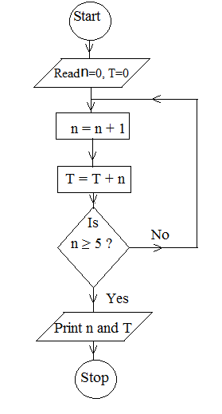

1. Perform a dry run for the flow chart.
2. State the purpose of the flow chart. ***(5 marks)***
3. An elastic string of natural length 60cm is stretched to 70cm by a stone of mass 1.5kg hanging on it. Find the,
4. modulus of elasticity of the string.
5. energy stored in the stretched string at equilibrium. ***(5 marks)***
6. The probability that Blessing goes for work using a taxi is $\frac{2}{3}$ and her probability of arriving early for work when she use a taxi is $\frac{3}{4}$. If she uses a private means, her chance of arriving late is $\frac{1}{3}$.
7. What is the probability that that she arrives early for work on a given day.
8. If she arrives early, what is the probability that she used a private mean?

***(5 marks)***

**SECTION B (60 MARKS)**

***Attempt any five questions***

1. A continuous random variable R has a probability density function (pdf), f(r) shown graphically below

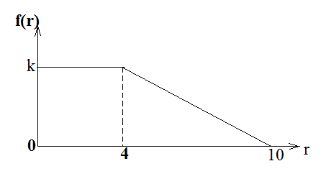

1. Find the,
2. value of k
3. expression of the pdf, f(r)
4. determine the distribution function (c.d.f) of R and sketch it.
5. Calculate $P(3≤R<7)$***(12 marks)***
6. Two cars A and B are proceeding one on each road, towards the point of intersection of two roads which meet at an angle of 600. If the speeds of A and B are $20kmh^{-1}$ and $32kmh^{-1}$ and are 70m and 40m respectively from the cross road, and the cars maintain their speeds, determine the
7. speed of B relative to A.
8. time when they are nearest to each other.
9. the distance of B from the cross road when they are nearest to each other. ***(12 marks)***
10. (a) Use the trapezium rule with equal width of $\frac{π}{6}$ to estimate

$\int_{0}^{\frac{2π}{3}}{\left(x-\sin{x}\right)}dx$. Give your answer correct to 3 decimal places.

(b) Determine the percentage error made in the estimation. ***(12 marks)***

1. The table below shows marks scored by 8 students in UNEB final examination mock examination.

|  |  |  |  |  |  |  |  |  |
| --- | --- | --- | --- | --- | --- | --- | --- | --- |
| UNEB | 79 | 67 | 52 | 71 | 97 | 55 | 41 | 86 |
| Mock | 75 | 60 | 45 | 55 | 85 | 43 | 30 | 70 |

1. (i) Draw a scatter diagram for the data.

(ii) On the same diagram draw a line of best fit.

(iii) Use the line of best fit to estimate the mark that a student who scored 68 in Mock will score in UNEB.

1. Calculate the rank correlation coefficient for the marks in Mock and UNEB and comment on your result. ***(12 marks)***
2. (a) Forces of magnitude 4,1,2 and 3N act along sides AB, BC, CD and AD respectively of a

rectangle ABCD in which $AB=4m$ and $BC=3m$. Given that the direction of the forces

are indicated by the order of the letters, determine the,

1. Magnitude of the resultant force.
2. Length AT, where T is a point on AB where the line of action of the resultant force cuts AB.

(b) A non-uniform ladder AB of weight 78.4N and length 5m is freely suspended

horizontally by two light inelastic strings AC and BD that make angles of ${30}^{0}$ and ${40}^{0}$

respectively with the upward vertical. Find the distance from A where the weight of

the ladder acts. ***(12 marks)***

1. (a) The height of the top of a ladder of length $l$ resting against a vertical wall making an angle of $θ^{0}$ with the horizontal is given by $h=l\sin{θ}$.
2. Show that the maximum relative error made in estimating the height $h$ is given by $\left|\frac{∆l}{l}\right|+\left|\frac{∆θ}{\tan{θ}}\right|$, where $∆l$ and $∆θ$ are the respective errors in $l$ and $θ$.
3. Find the maximum relative error in $h$ if $l$ and $θ$ are measured to be $3.96m$ and ${59}^{0}$ respectively.

(b) The length and width of a rectangle are measured as 4.5m and 2.4m with percentage

errors of 5% and 2% respectively.

Determine the,

1. range within which its area lie.
2. maximum possible error made in estimating its perimeter. ***(12 marks)***
3. (a) Mariam’s probabilities of passing Physics, Economics and Mathematics are

$0.6, 0.75, and 0.80$ respectively.

1. Find the probability that she passes at least two subjects.
2. If it is known that she passed at least two subjects, what is the probability that she failed Economics?

(b) At a certain fuel station, 30% of the customers buy Super (S), 60% buy Regular (R)

and the remainder Diesel (D). Of those who buy S, 25% fill their tank, 20% fill their

tank with D and 30% do not fill their tank with R.

1. Find the probability that when a vehicle leaves the station, it has a full tank
2. Given that a vehicle has full tank, what is the probability that the tank contains Diesel? ***(12 marks)***
3. (a) A car of mass 750kg is travelling along a horizontal road. If the resistance to the motion

total to 240N and the car’s engine is working at a constant rate of 12kW, find

1. the acceleration of the car when travelling at velocity of $20ms^{-1}$.
2. the maximum velocity of the car up a hill inclined at $\sin^{-1}\left(\frac{1}{25}\right)$ to the horizontal assuming the resistance remains constant.

(b) A brick of mass 0.8kg slides 6 metres down a plane inclined at $\sin^{-1}\left(\frac{3}{5}\right)$ to the

horizontal. If at the top of the plane, the brick is given an initial speed of $0.4ms^{-1}$, and

at the bottom it has speed of $5.4ms^{-1}$. Calculate

1. work done against resistive force.
2. Magnitude of the resistive force ***(12 marks)***

**END**